# CK Checkered Chunkies

Product Details:

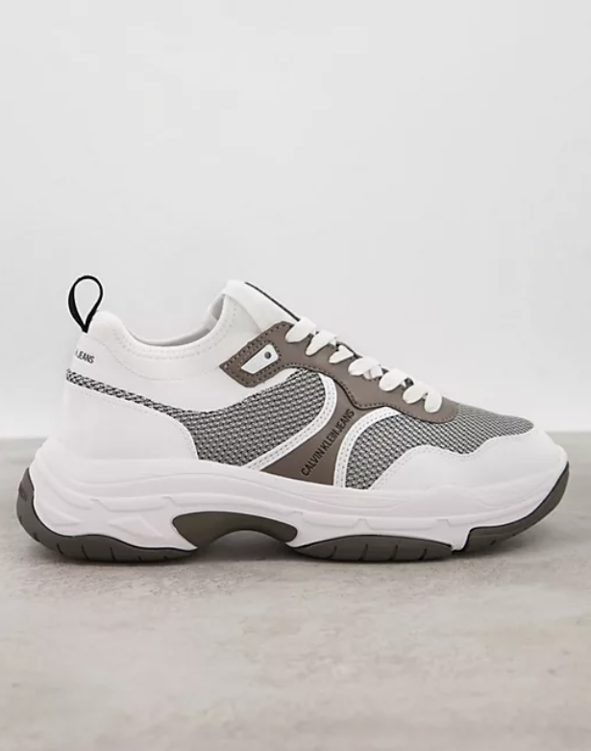

Color Combination: White sole, chocolate brown upper and back, checkered print on sides.

Material: High-quality synthetic materials ensuring durability and style.

Sole: Chunky white sole for added comfort and trendy appeal.

Closure: Lace-up closure for a secure fit.

Branding: Signature CK logo subtly incorporated on the tongue or side panel.

Versatility: Suitable for various occasions, from casual outings to relaxed gatherings.

Comfort: Padded insole and cushioned collar provide all-day comfort and support.

Style Tip: Pair with jeans, chinos, or even casual shorts for a versatile and fashionable look.